Temasek Polytechnic
School of Informatics and IT

Diploma in Information Technology (IT)

Software Requirement Specifications (SRS)

Project Particulars

Tutor | Mr Qi Yutao
Class | P02
Project Title | Delonix Regia Hotel Management System

Project Team’s Particulars

Matric Number | Student Name
1301676A | Mohamed Nisar Faizal
1301183H | Ronald Ng
1300506A | Syazwani binte Saharoni
1307306I | Mervin Neo

Table of Contents

1. DISTRIBUTION OF WORKLOAD 3
2. OVERVIEW OF REQUIREMENTS 3
2.1 System Functions 3
2.2 User Characteristics 5
2.3 General Constraints 6
2.4 Functional Requirements 7
2.5 Data Requirements 12
2.6 User Interface Requirements 17
2.7 Interface with Other Systems 20
2.8 Assumptions 20
3 OPERATIONAL AND QUALITY REQUIREMENTS 21
3.1 Operating Environment 21
3.2 Development Constraints 21
3.3 Performance 22
3.4 Availability 23
3.5 Security and Access Control Requirements 23
4 SPECIAL REQUIREMENTS 24
5 REFERENCES 24

DISTRIBUTION OF WORKLOAD

Requirement Gathering | Members
System Functions | Faizal
User Characteristics | Syazwani
General Constraints | Ronald
Functional Requirement | Syazwani
Data Requirements | Ronald
User Interface Requirements | Mervin
Interface with other systems | Mervin
Operational Requirement  (Operating Environment) | Faizal
Development Constraints | Faizal
Performance | Faizal
Availability | Faizal
Security and Access Control Requirements | Faizal

OVERVIEW OF REQUIREMENTS

System Functions
There are 3 modules in total which are going to be in the Hotel Management System. I will state the functions according to each module.

- Booking module
- Making a booking for hotel room/s – This function is for guests to be able to book a room in the hotel through the staff by providing the required details.
- Viewing available rooms – This function is for the staff to be able to see which rooms they can allocate to the guests according to their booking dates and choice of room type.
- Updating booking – This function is for update of any guest detail changes such as increasing the number of adults staying in the hotel room that the guest booked.

- Housekeeping and Staff Management module
- Viewing Hotel Staff details - This function allows management users and hotel administrators to view the various information of the hotel staff including the different duties they are able to do.
- Keeping track and updating of Staff particulars - This function allows the company to keep track of their current employees, ex-employees and any new staff they would like to employ. It also allows them to keep record of the updated particulars of staff.
- Viewing Housekeeping duties – This function allows the management to see the different housekeeping duties of all the staff.

- Reporting module
- Generating/Previewing Room Status report – This function generates a report that will list all the rooms in the hotel and its status to determine whether the room is vacant, occupied or scheduled for cleaning.
- Generating/Previewing Room Occupant report - This function generates a report that will list all the occupants in the respective rooms.
- Generating/Previewing Room Booking Information report - This function generates a report that will list all the names of the people staying in the whole hotel through the whole year, it is a report that can show the list of names staying in the hotel room on a specific date.
- Generating/Previewing Room Occupancy report - This function generates a report that will show room occupancy statics on a weekly, monthly and yearly basis. A report only accessible by the management.
- Generating/Previewing Housekeeping report - This function generates a report that will show housekeeping schedules for the staff based on the 4 different duties. Accessible to the management and administrators.
- Printing Reports - This function allows the above 5 reports to be sent to the printer and be printed.
- Exporting Reports - This function allows the above 5 reports to be exported in excel spreadsheet for the company’s need.

User Characteristics
There are 3 users in total who are going to use the modules mentioned above: -Reception Staff, Management and Hotel Administrator.

Hotel Reception Staff
The receptionist role would be to attain the goals of booking and to ensure guests are treated with high standard and high quality of customer service. The receptionist will perform his/her duties such as registering or updating guest’s information to the system, make reservations, sending emails for booking confirmation. When guests checked in, the staffs have to check for room availability and gather guest’s particulars. On top of that, the reception staffs have to check if the rooms are ready for the customers to check in. This is to avoid double booking by the staffs and to avoid any rooms that have yet to be cleaned. The management would consider hiring receptionist who has good standard of education such as English, Math and basic knowledge of IT for interacting, cashiering and managing the system purposes and hire a receptionist with good personality.

Management User
The manager is responsible for managing resources. The management will be able to access just like the hotel receptionist but in addition to that the manager are able to take all reports available from the system. The manager will also be able to add new, update and removing staff or guests from their system. If there is any complains made by the guests they are able to view which staffs were the one that provide them with service (e.g. receptionist that check them in and out or housekeeping staff that clean their rooms).

Hotel Administrator
The hotel administrator who is Mr. Wang, Mr. Wang would have access to everything from the module including monitoring and authorizing all the information and tasks. Mr. Wang would be able to have access to users account and log in modules. As Mr. Wang will be in charge of the hotels he would have access of all modules to keep track and receive updates himself. In these modules, Mr. Wang would able to have information of the staff and the guests and on top of that, he is able to retrieve, update or delete any particulars. Mr. Wang would also be able to view the duties made by his staff and view if they have completed them. In this way it is easier for him to get updates first hand and to take note of the feedbacks and complaints made by both the guests and the staff.

General Constraints
The software developing team will provide put in our best effort to develop the hotel system. However there will still be a few general constraints that might affect the software. The following constraints are:

- Time Constraints
Due to the short period of time given to develop the software, the team will focus on meeting the client’s entire requirement for the software. Additional features will be implemented if there is extra time. For example the housekeeping system can be turned into an app and be deploy to the mobile/tablet platform to provide portability for the stuff but due to time constraints this will not be implemented. So with the limited time, the team will develop a simple but realistic interface system using affordable technology. The software will be developed in a way that is it will be easily maintain and highly reliable, able to last for 10 years estimated.

- Budget Constraints
Due to the limited budget the mobile/tablet app cannot be deploy also because the company might have the budget to purchase smart devices that have a 512Mb ram minimum to house the app. On the other hand, due to the limited budget the company cannot have source for any more professionals to aid the development of the software. Therefore, the team will only consist of the 4 full time developers and the team of 4 will be in-charge of developing every parts of software and eventually testing it. As promised, the overall interface will be simple but the software will be able to accomplish the task hence, improving the hotel productivity. Another point is that with the limited amount of budget, the time only can source for affordable technologies and to develop the software. Some of this software might not have features that can increase the quality of the software so it will be task orientated and minimum additional feature implemented.

- Policy constraints
Due to the strict policy, some data such as the housekeeping reports and Room occupancy report are only accessible by the administrators and management. The complexity of the software is therefore increase. Hence, this will take the developing team to spend more time in designing and coding this function. So in order to retrieve the data of the reports, the system will be having a login function for the management and administrator personnel to key in their user and password.

Functional Requirements
Functional requirements portray the fundamental actions that the system should allow. The functional requirements have 5 main categories that is Check-In, Check-Out, Housekeeping, Staff Management and Report.

Booking - Check-In
- The system shall allow recording of reservation.
- The system shall allow recording of guest’s first name.
- The system shall allow recording of guest’s last name.
- The system shall allow recording of number of adults.
- The system shall allow recording of number of children.
- The system shall allow recording of guest’s phone number.
- The system shall allow recording of guest’s email address.
- The system shall allow recording of guest’s home and building address.
- The system shall allow recording of guest’s street address.
- The system shall allow recording of guest’s block address.
- The system shall allow recording of guest’s home postal code.
- The system shall allow recording of guest’s country.
- The system shall allow recording of preferred check-in date.
- The system shall allow recording of room type.
- The system shall allow checking of room availability.
- The system shall allow recording of room rates.
- The system shall allow recording of changes in room rates.
- The system shall allow recording of extension of number of stay.
- The system shall allow recording of room number.
- The system shall allow recording of preferred check-out date.
- The system shall allow recording of number of nights stayed.
- The system shall allow recording of additional remarks/requirements
- The system shall allow recording of late check out.
- The system shall allow recording of payment details.
- The system shall allow choosing of cash or credit card payment.
- The system shall allow recording of card number.
- The system shall allow recording of cardholder’s name.
- The system shall allow recording of expiration date.

Booking - Check-Out
- The system shall require guest to check-out before 12pm.
- The system will allow late check out if stated.
- The system will require full day payment if guest check-out after 12pm.
- The system will require room keys.
- The system will require remarks if guest consume anything from the mini bar.
- The system shall allow recording of payment invoice.
- The system shall require recording of anything consumed from the mini bar.
- The system shall require recording of check-in date.
- The system shall require recording of check-out date.
- The system shall require recording of number of days stayed.
- The system shall require recording of number of nights stayed.
- The system shall require recording of guest details.
- The system shall allow recording of guest’s first name.
- The system shall require recording of guest’s last name.
- The system shall require recording of number of adults.
- The system shall require recording of number of children.
- The system shall require recording of guest’s phone number.
- The system shall require recording of guest’s email address.
- The system shall require recording of guest’s home and building address.
- The system shall require recording of guest’s street address.
- The system shall require recording of guest’s block address.
- The system shall require recording of guest’s home postal code.
- The system shall require recording of guest’s country.
- The system shall require recording of room rates.
- The system shall require recording of any additional cost.
- The system shall require recording of payment method.
- The system shall require recording of card number.
- The system shall require recording of cardholder’s name.
- The system shall require recording of expiration date.

Housekeeping
- The system shall allow recording of housekeeping.
- The system shall allow recording of guest’s first name.
- The system shall allow recording of guest’s last name.
- The system shall allow recording of guest’s room number.
- The system shall allow recording of job done.
- The system shall allow recording of staff name.
- The system shall allow recording of additional remarks.
- The system shall require staff to choose if they have completed the job.
- The system shall allow to the staff to click if the room is still vacant, occupied or scheduled for cleaning.

Staff Management
- The system shall allow recording of staff details.
- The system shall allow recording of staff’s employee ID.
- The system shall allow recording of staff’s position.
- The system shall allow recording of staff’s salary.
- The system shall allow recording of staff’s first name.
- The system shall allow recording of staff’s last name.
- The system shall allow recording of staff’s phone number.
- The system shall allow recording of staff’s email address.
- The system shall allow recording of staff’s home and building address.
- The system shall allow recording of staff’s street address.
- The system shall allow recording of staff’s block address.
- The system shall allow recording of staff’s home postal code.
- The system shall allow recording of staff’s country.
- The system shall allow recording of staff’s working hours.
- The system shall allow viewing staff’s duties.
- The system shall allow to view if the staff have completed cleaning the room or it is still scheduled for cleaning.
- The system shall allow to view the room number of the duties they completed.

Report
- The system shall allow generation of room status reports.
- The system shall allow previewing of room status reports.
- The system will list all the rooms in the hotel
- The system will list the status if the room is vacant, occupied or scheduled for cleaning.
- The system shall allow generation of room occupant reports.
- The system shall allow previewing of room occupant reports.
- The system will list all the occupants in the respective rooms.
- The system shall allow generation of room booking information reports.
- The system shall allow previewing of room booking information reports.
- This system will list the date and names of the people staying at the hotel throughout the year.
- The system shall list the guest’s first name.
- The system shall list the guest’s last name.
- The system shall list the number of adults.
- The system shall list the number of children.
- The system shall list the guest’s phone number.
- The system shall list the guest’s email address.
- The system shall list the guest’s home and building address.
- The system shall list the check-in date.
- The system shall list the check-out date.
- The system shall list the number of nights.
- The system shall allow generation of room occupancy reports.
- The system shall allow previewing of room occupancy reports.
- The system will list the room occupancy statics on a weekly, monthly and yearly basis.
- The system shall allow generation of room housekeeping reports.
- The system shall allow previewing of room housekeeping reports.
- The system will list the housekeeping schedules for the staff based on their different duties.
- The system shall allow printing of reports.
- This system shall allow all reports to be sent to the printer and be printed.
- The system shall allow exporting of reports.
- The system shall allow all reports to be exported in excel spreadsheet for the company’s need.

Data Requirements
(Data dictionary)

Entity Name | Entity description | Column Name | Column Description | Data Type | Length | Primary Key | Nullable | Example
Staff Manegement | The data that records the particulars of all the staff that works in the hotels. | Staff_ID | NIL | Varchar | 10 | True | Does not allow null | S010101
 |  | Staff_First_Name | First name of the staff | Varchar | 50 | False | Does not allow null | James
 |  | Staff_Last_Name | Last name of the staff | Varchar | 50 | False | Does not allow null | Lum
 |  | Staff_Address | Address of the staff (Consisting of street name, blk number, postal code and country) | Varchar | 50 | False | Does allow null | Blk 14 Upper Boon Keng Road #09-1089 Singapore 380014
 |  | Staff_Hp_Num | Mobile phone number of the staff | Integer | 10 | False | Does not allow null | +6593944021
 |  | Staff_Email | Email of the staff | Varchar | 100 | False | Does not allow null | AhTanSiao_gmail.com
 |  | Staff_ICNum | Identification number of the staff | Varchar | 10 | False | Does not allow null | S9531346B
 |  | Staff_Position | Staff position in the hotel. | Char | 20 | False | Does not allow null | Manager
 |  | Staff_Working_Hr | Working hours of the staff. | Integer | 2 | False | Does allow null | 8
 |  | Staff_Salary_Amount | The amount of salary that the staff draw | Integer | 6 | False | Does allow null | 4000
Booking (Check- in) | The data that records the guest particulars when they make a reservation for a hotel room | CheckIn_ID | Nil | Varchar | 10 | True | Does not allow null | CI20201
 |  | Guest_First_Name | First Name of the guest | Varchar | 50 | False | Does not allow null | Sean
 |  | Guest_Last_Name | Last name of the guest | Varchar | 50 | False | Does not allow null | Philips
 |  | Num_Of_Adult | Number of adult staying in the rooms | Integer | 2 | False | Does not allow null | 4
 |  | Num_Of_Children | Number of children staying in the room | Integer | 2 | False | Does not allow null | 2
 |  | Guest_Ph_Num | Phone number of the guest | Integer | 12 | False | Does not allow null | +6587322041
 |  | Guest_Email | Email address of the guest | Varchar | 50 | False | Does not allow null | Sean_Sean@hotmail.com
 |  | Guest_Address | Residential address of the guest (Consist of street name, block number, postal code and country) | Varchar | 50 | False | Does not allow null | Sky Residences Blk 2 Heaven Road #10-01  Singapore 990001
 |  | Num_of_Nights | The number of nights that the guest want to stay in the hotel | Integer | 3 | False | Does not allow null | 4
 |  | Guest_Check_in_Date | The date that the guest would like to check in | Date | DD/MM/YYYY | False | Does not allow null | 12/05/2015
 |  | Preferred_Room | The type of room preferred by the guests. | Vachar | 20 | False | Does not allow null | Deluxe Room
 |  | Room_availbility | The availability on the type of room the guest preferred. | Varchar | 20 | False | Does not allow null | Available
 |  | Room_Rate_Per_Night | The room rate per night on the room they guest booked | Decimal | 8 | False | Does not allow null | 220/night
 |  | Num_Stay_Extension | The number of nights that the guest wants to extend. (If any) | Integer | 2 | False | Does allow null | 3
 |  | Room_Allocated | The room allocated to the guest during their stay. | Varchar | 20 | False | Does not allow null | Deluxe Room
 |  | Guest_Check_Out_Date | The date that the guest would like to check out | Date | DD/MM/YYYY | False | Does not allow null | 16/06/2015
 |  | Guest_Add_Request | Guest special request and remarks to the staff to let them know certain needs they require during their stay | Varchar | 100 | False | Does allow null | Additional single bed
 |  | Guest_Payment_Method | The method  That the guest use to settle the pays | Char | 10 | False | Does not allow null | VISA
 |  | Guest_Card_Num | The card number of the credit/debit to finish to book the room | Integer | 20 | False | Does not allow null | 4321 2345 5678 1234
 |  | Guest_Card_Name | The name of the credit card used by the guest. | Char | 50 | False | Does not allow null | Sean Philips
 |  | Guest_Card_expiry_Date | The date of card that will expiry | Date | MM/YYYY | False | Does not allow null | 12/2019
Booking  (Check –out) | The data that records the entire process of guest that has check-in throughout. | CheckOut_ID | NIL | Varchar | 10 | True | Does not allow null | C
 |  | CheckOut_Status | The status of a check out of the guest and late checkout will be recorded and charge accordingly. | Varchar | 20 | False | Does allow null | CO30301
 |  | Room_Key_Status | The status of the room keys whether they are returned or yet to return | Varchar | 10 | False | Does not allow null | Returned
 |  | Mini_Bar_Status | To record any food or drinks are indulged by the guest during the stay and must be charged | Varchar | 50 | False | Does allow null | No items taking out
 |  | Payment_Invoice_Status | Whether payment has been processed and invoice issued to the guest. | Varchar | 20 | False | Does not allow null | Issued
 |  | Additional_Cost | Any additional cost during the guest stay will be all accumulated. | Decimal | 6 | False | Does allow null | NIL
 |  | Final_Cost_W/O_Tax | The final amount after adding the additional cost if any. | Decimal | 10 | False | Does not allow null | 526.34
 |  | Final_Cost_W/Tax | The final amount with the inclusion of tax | Deciaml | 10 | False | Does not allow null | 560.78
Housekeeping | Data that is recording to ensure all the housekeeping are carry out by staff as scheduled | Housekeep_ID | NIL | Varchar | 10 | True | Does not allow null | HO40401
 |  | Cleaning_status | The cleaning status of the room recorded | Varchar | 10 | False | Does not allow null | Housekeeping done
 |  | Guest_Name_Request_HouseKeep | Name of the guest who requested for housekeeping | Char | 50 | False | Does allow null | Gina
 |  | Room_num_Housekeep | Room Number of the room being housekeep | Integer | 4 | False | Does not allow null | 12-02
 |  | Staff_Name | Name of the staff that carried out the housekeeping | Char | 50 | False | Does not allow null | Ronald
 |  | Add_Remarks | Any other additional remarks to the housekeeping | Varchar | 100 | False | Does allow null | Nil
 |  | Time_of_Housekeep | The time the housekeeping was done | Time | NIL | HH:MM:SS | Does not allow null | 12:03:44

User Interface Requirements
There will be different user interface screens in the system. These screens are -
- Login screen - allows users to login to the system either as a customer or the hotel staff.
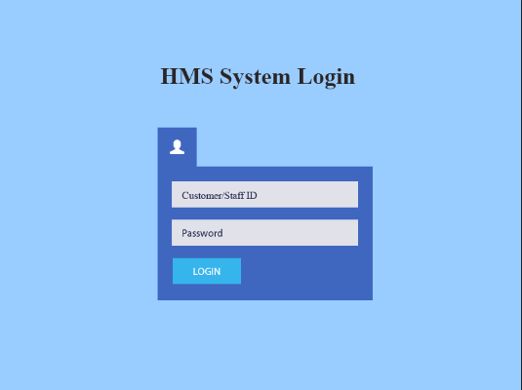

- Booking screen - allows users to create a new booking, retrieve their booking information, update their booking and cancel their booking.
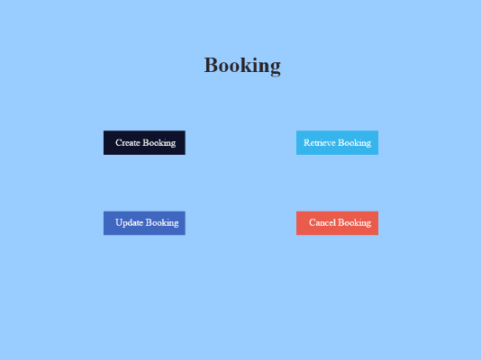

- Check-in screen - allows users to modify their room stay and check-in to their rooms.
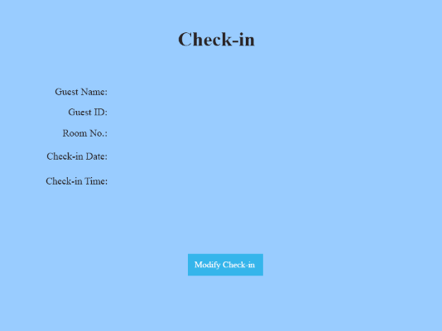

- Checkout screen – allows users to checkout
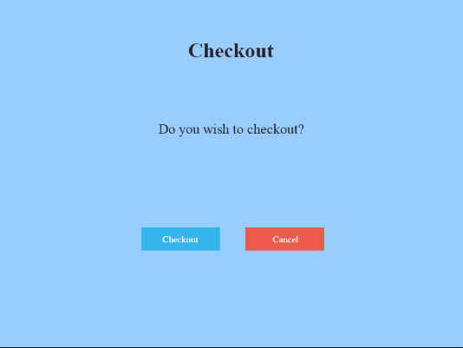

- Customer Record screen – allows user to add or update the customer records
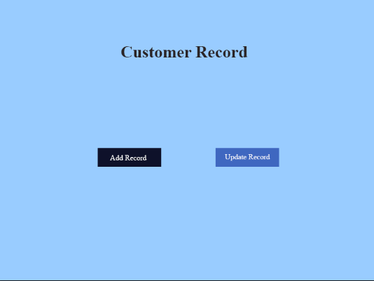

- Administer Rooms screen – allows user to check the availability and rates of the different rooms
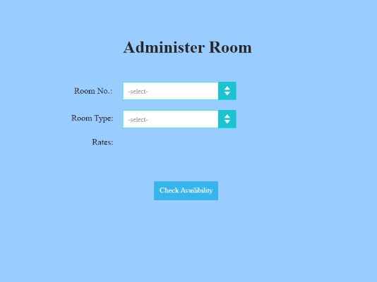

- Administer User screen – allows user to create, modify, and delete users and also change their password.
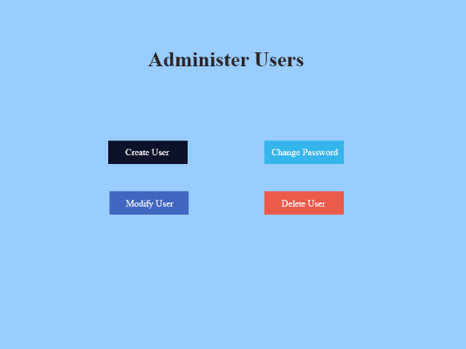

Interface with Other Systems
The Hotel Management System shall transmit the customer’s and receptionist’s commands like the making of booking and the checking in time and the administrator shall execute the commands received. The specification for interfacing would be the possible actions that the end users, whom are the customer and receptionist, may perform. An example would be the action where the customer would use the system to check for room availability.

Assumptions
- Mr. Wang will be prepared to purchase or upgrade desktop computers and accessories to be able to run the HMS properly.
- Broadband connection is fast enough for VDI software to work

OPERATIONAL AND QUALITY REQUIREMENTS

Operating Environment
The operating environment that the system will be deployed in will be at the administrator room’s computer. The system will also be deployed in the reception counter’s computer. They can make use of one main copy of the system which is located at the administrator room. This can be done through software such as Virtual Desktop Infrastructure (VDI) where different screens can be used in different desktops making use of the master system copy. The VDI software makes use of the broadband connection which the hotel has. The team has chosen this method as it will provide convenience to all the users of the system because they each possess different rights. For example when the management user wants to look through the staff management module to update staff particulars, he need not go down to the reception to use the computer to access it. It will be either he has to wait for the computer to be free for his usage or delay others such as the hotel guests if there is any checking in/out. So it would be convenient for everyone if he has a separate computer to do his work which is the one located in the administrator’s room.

Development Constraints
The constraints the team is going to face in development are as such
- Time/Schedule – As there are 3 different modules to be implemented with only 6 weeks left, time is definitely a limited resource. On average each module must take no more than 2 weeks to complete. In this 2 weeks the specification gathering, architectural designing, database designing, User Interface designing, implementation, testing and deployment must all be done. Adding on the 3 modules must be combined into the same system without any errors. Furthermore since our team is following the Evolutionary Prototyping model, time must also be allocated to the refinement of each module. Thus time is a major constraint.

- Platform – Since Mr. Wang’s hotel doesn’t have proper IT resources, the team has to research and shop for the best and most suitable IT products for the hotel’s usage. On top of that the team itself also needs proper and reliable development computers to work with so as to minimize any time lost due to software development crashes or etc.

- Working as a team – Due to the other projects we have in hand and the group members’ different schedules, the team is not able to work together most of the time costing us to be slightly less efficient.

Performance
We will break up the response time of the system into the 3 modules. Firstly the Availability of Booking module will have a fast response time of few seconds to process the various booking functions as its only creating/updating records in the database. The Reporting module will take a longer time as it needs to collect and organize the data from the system. The functions of generating the reports or exporting them into spreadsheets will take few minutes, around 5-15 minutes, depending on the different amount of data the reports need. Lastly is the Housekeeping and Staff Management module. The functions under this module will also take about few seconds to respond as its only creating/updating records in the database.

One factor which may affect the response time of the system at the reception’s computer is the speed of the broadband connection. If the broadband connection’s speed is not too slow, the response time is not affected. However if it is too slow, response time may take longer as the VDI software makes use of the broadband connection. Another factor which may affect response time is when both computers are used at the same time. Response time may become a few seconds longer for Availability of Booking and Housekeeping and Staff Management modules and few minutes longer for Reporting module. The usage timing of the computers (i.e. Peak/Non-Peak hours) does not affect response time as only maximum of 2 computers is being used at the one time.

Availability
Since the hotel must allow check in/out at all times, the system must be running 24/7 to be able to process the functions. Both the system at the administrator room and the VDI software for receptionist usage must be up and running. However for each week the system will require about 3 to 4 hours for backup of data and maintenance of the system if required. During this time, the system can’t be accessed in both computers. This process can be done on any scheduled day of each week when there are not much customers checking in/out. Most preferable time would be past midnight and before dawn. During this period if there are any hotel guests wanting to check in/out, the staff have to take down their information manually and allocate rooms based on the Room Status Report.

Security and Access Control Requirements
The users of this system are grouped into 3, Reception staff, Management users and Hotel administrators. Reception staff have access to Reporting and Availability of Booking modules excluding the Room Occupancy and Housekeeping reports in the Reporting module. Management users have access to Reporting, Housekeeping and Staff Management and Availability of Booking modules. Hotel Administrators have access to Reporting module excluding Room Occupancy report, Housekeeping and Staff Management module and Availability of Booking module in addition to all user accounts and log in creation modules. Each of them will have their own account credentials in the system.

As for the reception staff, since we are implementing VDI, it will require their login credentials to identify that they are the hotel staff. One common login credential may be used in behalf of all the hotel staff to avoid extra management of this account credential information. On top of that the HMS will require their individual account credentials to login to the system. However only access to the reporting and booking modules are open for their usage. Access will be denied if the receptionist staff tries to access the Housekeeping and Staff Management module.

As for the Management users and Hotel Administrators, they also follow the same rule. Since they have a separate desktop to work on, they won’t be in need of using the reception computer although they may do so in need. They will have their own individual account credentials for logging in. The system will determine the user type based on the credentials and will open up the different modules they are able to access.

SPECIAL REQUIREMENTS

There is one other special requirement for this system. It is the main developer access which allows the user to get into the system files for maintenance or upgrading purposes. This user account is also needed to do backup of data into another database. Thus this user account will be only used once per week during the system maintenance and data backup process or whenever else it is needed. The credentials for this account is only known to the developer, maintenance man and Mr. Wang himself.

REFERENCES

NIL

